**DAILY ONLINE ACTIVITIES SUMMARY**

|  |  |  |  |  |  |  |  |  |
| --- | --- | --- | --- | --- | --- | --- | --- | --- |
| **Date:** | **18/06/2020** | | | | | **Name:** | **Katira Krishna J** | |
| **Sem & Sec** | **8th A** | | | | | **USN:** | **4AL16CS045** | |
| **Online Test Summary** | | | | | | | | |
| **Subject** | | **SMS** | | | | | | |
| **Max. Marks** | | **60** | | **Score** | | | **Marks not received** | |
| **Certification Course Summary** | | | | | | | | |
| **Course** | **Data Analysis with python** | | | | | | | |
| **Certificate Provider** | | | **Cognitiveclass.ai** | | **Duration** | | | **10 hours** |
| **Coding Challenges** | | | | | | | | |
| **Problem Statement: Python program to compute a polynomial equation given that the coefficients of the polynomial are stored in a list.** | | | | | | | | |
| **Status: Completed** | | | | | | | | |
| **Uploaded the report in Github** | | | | | **Yes** | | | |
| **If yes Repository name** | | | | | **Krishna_Katira** | | | |
| **Uploaded the report in slack** | | | | | **Yes** | | | |

Online Test Details: Mail Not Received

Certification Course Details:

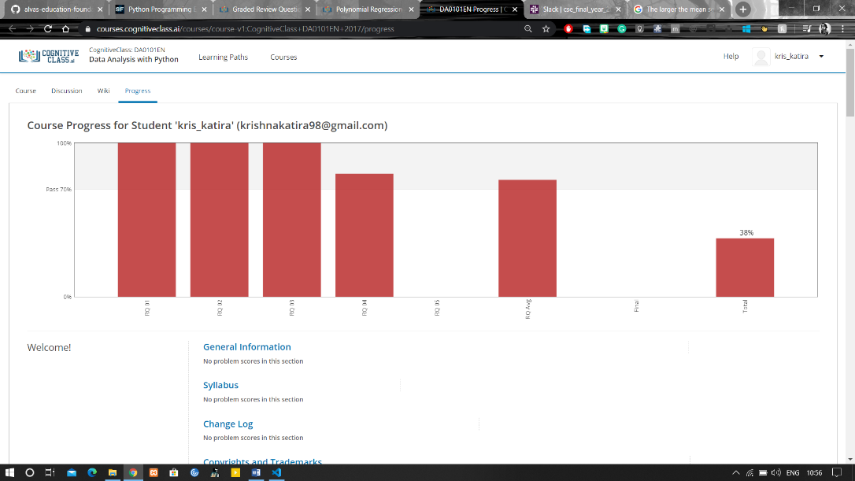

Coding Challenges Details:

**Program:**

import math

print("Enter the coefficients of the form ax^3 + bx^2 + cx + d")

lst=[]

for i in range(0,4):

a=int(input("Enter coefficient:"))

lst.append(a)

x=int(input("Enter the value of x:"))

sum1=0

j=3

for i in range(0,3):

while(j>0):

sum1=sum1+(lst[i]*math.pow(x,j))

break

j=j-1

sum1=sum1+lst[3]

print("The value of the polynomial is:",sum1)